**ATP CONTROLLER**

|  |  |  |
| --- | --- | --- |
| Vivekanandan.M  Assisant Professor  Department of Artificial Intelligence *and Data science*  Rajalakshmi Institute of Technology vivekanandan.in@ritchennai.edu.in    Sri Ganesh.S  Artificial Intelligence and Data Science  Rajalakshmi Institute Of TechnologyChennai,India sriganesh.s.2021.ad@ritchennai.edu.in | O.Pandithurai  Associate Professor  Department of Computer Science and  Engineering  Rajalakshmi Institute of Technology  pandies@ritchennai.edu.in    Rishikesh.K  Artificial Intelligence and Data Science  Rajalakshmi Institute Of Technology  Chennai,India  rishikesh.k.2021.ad@ritchennai.edu.in | G.Sai Krishnana  Department Of Mechanical  Engineering  Rajalakshmi Institute Of Technology saikrishnan.g@ritchennai.edu.in    Nitheesh.S  Artificial Intelligence and Data Science  Rajalakshmi Institute Of Technology  Chennai,India  nithesh.s.2021.ad@ritchennai.edu.in |

# **ABSTRACT**

Anytime Electricity Bill Payment Controller is a concept or device that allows the user to pay the electricity bill at any time, regardless of the location or working hours of the electronic payment facility. The controller acts as an intermediary between the user and the utility, providing flexibility and flexibility in the utility.

All-Time Electronic Payment Management works in integration with multiple payment gateways and tools. It provides a user-friendly interface that allows customers to easily initiate and complete bill payments using various payment methods such as credit/debit cards, mobile wallets or online banking.

each time the abstract invoice The main responsibilities of the Controller will include:

1.Accessibility: Controllers must be accessible through a variety of methods such as web-based platforms, mobile apps, and even interactive voice response (IVR) to meet the many needs of user needs.

2. Actual Billing Information: Admin must provide up-to-date billing information including current charges, due dates and balances to confirm accurate and up-to-date billing information.

3. Multiple payment options: Regulators should encourage multiple payment methods to suit customer preferences, including online payments, wire transfers, and offline options such as cash collection points or kiosks.

4. Security: Security measures should be taken to protect users' sensitive payment information from unauthorized access or fraud.

5. Notifications and Reminders: The controller can send notifications and reminders to users about payment deadlines, important fees or payment confirmations via email, SMS or in-app notification.

444 6.

Payment History and Receipts: Admin will manage transaction history, allow users to view past payments, download receipts and generate reports for usage and storage.

By offering a solution where they can pay their electricity bills every time, customers can easily pay their electricity bills whenever they want and with any payment method, thus improving user satisfaction and the entire payment process.

## **INTRODUCTION**

Always Electric Bill Payment Management is an innovation designed to provide customers with the convenience and convenience of paying their electricity bills. Traditionally, customers have had to adhere to certain payment schedules and hours of operation from their energy providers, often limiting their ability to pay their bills whenever they want. However, with the introduction of the Electricity Term Bill Payment System, customers will now be able to pay their bills whenever and wherever they want.

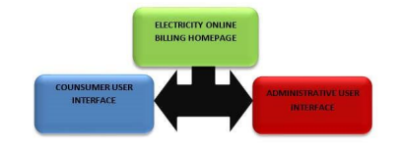

The Controller acts as an intermediary between customers and utilities, simplifying the payment process and providing many features to improve the overall user experience. Customers can initiate payments through multiple platforms such as websites, mobile apps or IVR systems, integrating with various payment platforms and tools.

One of the main benefits of Always Electric Bill Payment Checker is its ease of use. Users can access the system at any time without having to visit physical payment centers or follow limited working hours. Whether early in the morning or late at night, customers can solve their electricity bill without any time limit.

In addition, the controller provides customers with real-time billing information, keeping them up-to-date on their electricity bills. This includes current payment, due date and outstanding balance.

Armed with the right information, customers can make informed decisions and plan their payments accordingly.

Electronic payment systems always offer various payment methods to meet the preferences of different users. Users can choose from a variety of payment methods, including credit/debit cards, mobile wallets, online banking and even offline payment methods such as cash collection points or kiosks. This change allows customers to choose the payment method that works best for them, making the job easier and meeting different financial preferences.

Strong security measures are implemented in the controller to ensure the security of user payment information.

This helps protect sensitive information, prevents unauthorized access or fraud, and gives customers peace of mind when paying.

Also Always Electric Bill Payment Controller provides notifications and alerts to users. Via email, SMS or in-app notifications, customers can receive timely reminders about due dates, outstanding debts and confirmation of payment completion. These notifications act as reminders, reduce the possibility of missed payments and allow users to keep their electricity bills under control.

Additionally, the controller manages payment history allowing users to view past transactions, download receipts and generate reports as needed.

This program allows users to keep track of their payment information, simplify data storage and provide reference for future payments or disputes.

The

All-Time Electricity Billing System is collectively changing the way consumers pay for electricity. It provides users with more control and easy management of their electricity bills by providing easy access, real-time information, multiple payment methods, security measures information, reports and payment history.

### **LITERATURE SURVEY**

The purpose of generating an electricity bill at a time is to provide customers with a convenient and efficient way to pay their electricity bills. This literature review aims to discuss current research and technology related to electronic payments of all time, focusing on the field of electronic payments electricity. The survey covers a wide range of important topics, including payment methods, security, user experience and technological advances. The results of this research will form the basis for the design and development of an immediate cost-effective electric charge.

444 1.

All payment periods:

1.1. "Mobile Payment Systems: A Comparative Study" by Xiaoxiao Wu and Xiaolin Peng.

1.2.

"Evaluation of Online Payments" by Ioana Barbalau and Marian Cristian Mihaescu.

1.3. "Electronic Payment Systems Research" by Mohamed Riduan Abid and Noreen Izza Arshad.

444 2.

Electricity payment:

2.1. "The Design and Use of Automatic Fire Extinguishers" by Sunday Idowu, Oluwasegun Daniel and Oluwadare Joshua.

2.2.

"Smart Electricity Metering and Billing Systems: A Case Study" by Bhushan Jagyasi, Rohit Shukla and Abhishek Tiwari.

2.3. "Design and Implementation of Online Loan Payment System" by Awodele Oludele, Ajayi Oladimeji and Abidemi Oyelami.

444 3.

Security and authentication:

3.1. "Two-Factor Authentication: A Comparative Study", Z. A. Abdulnasiru and A.

hello.

3.2 a. "Security in Online Payment Systems: Analysis of Threats and Defenses", George Loukas.

3.3. "Evaluation of Security in Electronic Payments" by Ping Wang, Joseph W. Kuan, and Hong-Yi Wu.

444 4.

User experience and usability:

4.1. "Customer Experience in Mobile Banking" by Marc Hassenzahl and Polle T. Zellweger.

4.

2. Handbook of Mobile Payment Systems, Julia L. Meek and John V. Goodwin.

4.

3. "A Study on User Perceptions and Acceptance of Online Payments" by Chui Yin Wong and Tariq Mahmood.

5. Education:

5.1.

"Internet of Things (IoT)-Enabled Smart Grid Delivers Efficient Energy Management" by Yunbo Rao, Zhaoyu Liu, and jianhua zhang.

5.2 a. "Blockchain Technology for Security and Energy" by Francesco Longo, Gianpaolo Vitale and Antonino Mazzeo.

5.

3. "Air Connections in Smart Grids: A Review of Technologies and Methods", by Mohamed Amine Ferrag, Mohammed Atiquzzaman and Abdelouahid Derhab.

### **OBJECTIVES**

Convenience: The main goal is to provide convenience to customers so that they can pay their electricity bills at any time. This eliminates the need to visit physical payment centers during business hours, allowing customers to pay at times convenient for them, whether on weekends, holidays or off hours.

Availability: The purpose of the controller is to make it easier to pay bills for all customers. Online platforms require multiple payment methods such as mobile apps and voice chat. This enables customers to choose the most appropriate path based on their access to different technologies.

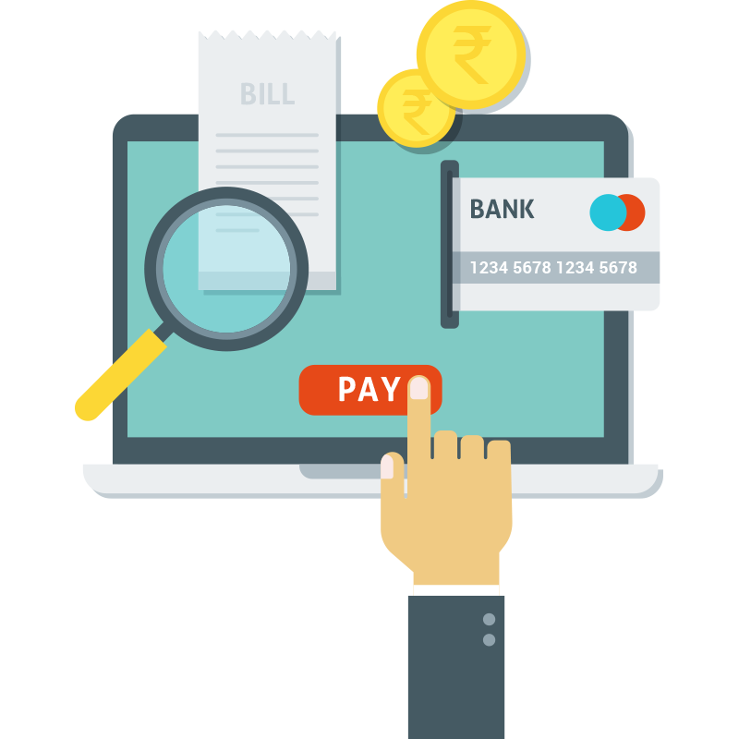

Timeliness: Another goal is to ensure that payments are made on time. Managers must have a process for retrieving payment information, verifying transactions, and updating customer accounts in real time. This reduces delays and ensures the accuracy and timeliness of payments.

Security: It is essential to maintain a high level of security for electronic payments at all times. Customers should use strong encryption techniques and security measures to protect payment information from unauthorized access or information leakage.

Flexibility: The controller should support different payment methods to suit different customers. It should allow payment by credit/debit cards, electronic money transfers, mobile wallets and other popular payment methods. This change allows customers to choose the payment method that suits them best.

Transparency: Payment transparency is key to building customer trust. Regulators should provide detailed and clear information to enable customers to easily understand what their electricity bills are.

It should also provide access to billing and usage data, enabling customers to track their spending and make informed decisions.

Customer Service: Those Who Always Pay Electricity Bills should have excellent customer service. Should have multiple methods of customer support such as phone, email or chat to resolve payment questions or concerns in a timely manner.

In general, the purpose of All Time Electronic Payments is based on providing convenience, accessibility, security, timeliness, flexibility, transparency and good customer service to increase customer satisfaction.

### **The outcomes of an anytime electricity bill payment controller can have several positive impacts, including:**

Increase customer satisfaction: By providing a convenient electronic payment platform, customers can easily pay their invoices at a convenient time. This increases customer satisfaction as it removes the hassle of visiting a physical payment center from time to time and allows customers to manage their payments at their own words.

Improved invoicing: Pay Anytime Management for timely completion of electronic payments. Payments can be made on time, and the system can quickly update customers, reduce delays and improve payment. This allows for accurate and timely invoicing and prevents late payments.

Enhanced convenience and flexibility: Controllers provide customers with greater convenience and flexibility by accepting payments through multiple channels, including online platforms, mobile apps, and social networks. They can choose the payment method that suits them best through their favorite online platform, mobile app or phone.

Enhanced Security: Perpetual Electronic Billing Systems often use security measures to protect customers' payment information. This includes encryption techniques, secure payment gateways and data protection. By keeping customer information secure, regulators can build trust and confidence in customers, encouraging them to pay without fear of data breaches or unauthorized access.

Reduced Billing Charges: With Payer All Time Management, the burden of managing electricity bills or utility bills is reduced. Automatic payments automate business processes and update customer accounts in real time, reducing the need for manual intervention and reducing human error. This simplifies the billing and payment process by freeing up resources to focus on other important activities.

Additional Revenue: The simplicity and practicality of Pay Anytime controllers can increase revenue for energy providers. By offering customers a variety of payment options and being timely, customers are more likely to pay their bills on time.

This reduces late payment fees and streamlines the entire tax process.

Data Quality Analysis and Insights: Payment Managers always collect valuable information about customers' payment patterns, preferences and spending. This information can be used for analysis and understanding of customer behavior, allowing energy suppliers to improve their services, adjust their marketing strategies, and consider information to increase customer satisfaction.

Overall, Electronic Bill Payments Anytime has made customer satisfaction, payment processing more efficient, easier, improved security, reduced cost control, increased revenue and provided useful information for energy providers.

### **While an anytime electricity bill payment controller offers numerous benefits, it also faces certain challenges. Some of the challenges include:**

Technical Infrastructure: The use of Futures Payments requires a technological infrastructure that can process large volumes of products and ensure the security of payments. It may require significant investments in hardware, software and network infrastructure to support seamless and reliable payments.

Connectivity and access: Having a stable internet connection or cell phone coverage can be difficult, especially in remote or rural areas. Untrusted internet or mobile services can limit the functionality of any payment management system by preventing customers from making payments via online platforms or mobile apps.

Digital literacy and sawing: Not all customers know or use digital platforms for payment.

Low digital literacy among certain consumer groups or a reluctance to use technology can present challenges in promoting and promoting the use of Payday Payments. Training and support may be needed to overcome these challenges.

Security Risks: Payment controllers always keep customer payment information in bad shape, making them a favorite target for cyber attacks and fraud. Effective security controls, including encryption systems, secure payment gateways, and regular security updates are critical to protecting customers' privacy information and preventing unauthorized access.

Integrate with Existing Systems: Integrating Anytime Pay Controller with existing billing and customer management systems can be difficult.

It may require coordination and integration of different software to ensure billing, return and update times for customers. If not handled properly, integration issues can delay the implementation process or cause poor performance.

Customer Service and Solutions: With Pay Anytime, customers may need assistance or have questions about the billing process, invoice discrepancies, or operational issues. Responding to and supporting customers effectively through a variety of channels such as phone, email or chat is essential to resolving customer issues and ensuring satisfaction.

Regulatory Compliance: Payment controllers must comply with various regulations and industry standards regarding data protection, privacy and payments.

Compliance with these regulations and compliance with changing standards can be difficult and may require continuous monitoring and updating of payment management systems and security measures.

### **Architecture of an anytime electricity bill payment controller**

The architecture of any real-time electronic payment management system consists of many components that work together to make payments efficient and secure. Below is an overview of the main components:

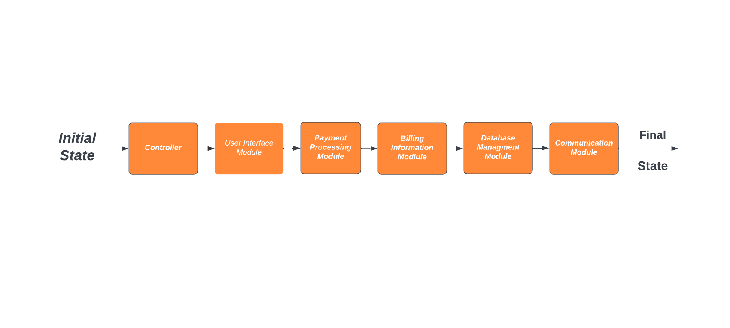

User Interface: The User Interface provides the front-end interface where the user interacts with the payment controller. It includes various websites such as web portals, mobile apps or voice chat. The user interface allows customers to view their invoices, choose payment options, enter payment details and get confirmation of successful transactions.

Payment Gateway: A payment gateway acts as a bridge between a payment controller and a financial institution or payment processor.

It securely processes payment information, verifies transaction details, and facilitates the transfer of consumer and electricity bills. Payment gateways can support multiple payment methods, including credit/debit cards, wire transfers, or wallet payments.

Integration Layer: The integration layer provides seamless communication and data exchange between the payment controller and other systems such as billing, management customers and accounting systems. It provides synchronization of payment information, updates customer accounts in real time and generates accurate payment information based on payment.

Billing and Financial Management: This product manages customer billing information, including billing, billing, and customer service.

It works with payment controllers to update customer accounts based on payment transactions and ensure accurate invoicing and related payments.

Security and Audit: Security is always the main focus of the Payroll Manager. It includes authentication mechanisms to authenticate customers and protect sensitive payment information. Encryption methods, Secure Sockets Layer (SSL), and tokenization can be used to secure data transfer and storage. Compliance with industry standards and regulations regarding data protection and payment security is essential.

Database and information management: Databases store and manage customer payment information, invoice details, transaction history, and other related information. It provides a secure and scalable storage environment for efficient processing and processing of data required for payment, reporting and analysis.

Reporting and Research: This component manages paid data-driven reporting, analytics, and insights. Payments can provide insight into customer behavior, revenue, and performance metrics. These insights help improve payment systems, identify areas for improvement, and make informed decisions.

External integration: It can be integrated with external systems and services such as Payment Controllers, third-party payment processors, financial institutions or service providers. These integrations lead to integration of payments, settlement and integration of disparate systems.

Alerts and Notifications: Payment Managers may include features that send notifications and alerts to customers about invoice due dates, payment confirmations, or payment changes. This can be done through various communication methods such as email, SMS or push notifications in mobile apps.

Pay Anytime Controller model will vary depending on requirements and technology used.

But these products work together to provide safe, efficient and easy payments for consumers and energy providers.

### **Hardware:**

Servers: High-performance servers are required to host software and manage payments, database transactions, and communications with other systems.

Network Infrastructure: A common communication system is required to provide a secure and reliable connection between the different components of the payment controller. This may include routers, switches, firewalls, load balancers and other network equipment.

Data Storage: Storage devices such as hard drives or solid state drives (SSDs) must store and manage billing information, customer information, and other related information.

Security Measures: Security devices such as firewalls, intrusion detection systems, and encryption devices can be implemented to protect systems from unauthorized access, data breaches, and other security threats.

### **Software:**

Payment Gateway Software: Payment gateway software simplifies payment security, transaction analysis, and integration with financial institutions or payment systems. Popular payment gateway software includes Stripe, PayPal, Braintree or custom solutions.

Database Management Systems: A reliable and scalable database management system (DBMS) must store and manage billing information, customer information, and other related information. Commonly used DBMSs include MySQL, PostgreSQL, Oracle or MongoDB.

Web/Application Framework: Depending on requirements, a web or application framework can be used to build user interface, backend logic, and integration.

Popular frameworks include Django, Ruby on Rails, Laravel or custom solutions.

Security Software: Use security software such as encryption libraries, SSL/TLS protocols, detection/intrusion prevention, and anti-virus/anti-virus software to keep information safe and protect against cyber threats.

Work Experience: Job selection is based on the organization's preference and affiliation with the software. Commonly used operating systems for web/application servers include Linux distributions such as:

, Ubuntu, CentOS) or Windows Server.

Monitoring and Analysis Tools: Monitoring tools such as Nagios, Zabbix, or Splunk can be used to monitor system performance, monitor business metrics, perform suspicious analysis, and generate reports.

Mobile App Development Frameworks: If mobile is part of the payment management system, frameworks such as React Native, Flutter or native development tools for iOS/Android can be used. It is worth noting that the specific hardware and software selected for use will depend on factors such as capacity requirements, budget, technical considerations, security, collaboration needs, and team building. The selection should be based on a clear analysis of the organisation's policies and objectives.

### **CONCLUSION**

Electricity Bill Payment Checker of All Time offers many benefits and solutions for consumers and electricity providers. Increase customer satisfaction and increase payment efficiency by making it easy and secure for customers to pay their invoices whenever they want. The standard controller usually includes components such as the user interface, payment gateway, security layer, security measures, database, and reporting/analysis tools. By using

Pay Anytime Controllers, organizations can provide easy, accessible, secure, timely, flexible, transparent and superior customer service. Customers appreciate the convenience of paying their bills at any time and with a variety of payment methods, reducing the need for personal visits or specific working hours.

Integrating the controller with existing systems ensures accurate billing, streamlines customer service, and enhances data analysis capabilities.

However, there are constant problems with the use of payment controllers. These challenges include enabling effective technology development, addressing connectivity and access barriers, promoting digital literacy and adoption, managing security measures design, integration with existing systems, providing customer support, ensuring compliance, and effectively managing change. Despite these challenges, all-time electronic payment management can deliver significant benefits such as increased customer satisfaction, increased billing, improved convenience and compliance, improved security, reduced management, increased revenue, and effective audit data.

Overall, Pay Anytime Electricity Bill Checker changes the payment experience, simplifies the process and provides greater convenience, usability and security for users, products and energy providers.

It plays an important role in improving invoicing and payment, supporting customers and increasing efficiency in the electronics industry.

### **REFERENCE LINKS**

[1] <https://www.researchgate.net/publication/337275192_DESIGN_AND_IMPLEMENTATION_OF_AN_ELECTRICITY_ON-LINE_BILLING_PAYMENT_SYSTEM>

Arimoro, T. A., Oyetunji, A. K., & Odugboye, O. E.

(2019). Analysis of Electricity Billing System in

Corporate Buildings in Lagos, Nigeria. Studies, 1(6),

10-20.

Arimoro, T. A., Oyetunji, A. K., & Odugboye, O. E.

(2019). Analysis of Electricity Billing System in

Corporate Buildings in Lagos, Nigeria. Studies, 1(6),

10-20.

Arimoro, T. A. , Oyetunji , A. K., & Odugboye, O. E. (2019). Analysis of Electricity Billing System in Corporate Buildings in Lagos , Nigeria. Studies, 1(6), 10-20.

[2]

https://www.ijert.org/implementation-of-iot-based-electricity-controlled-prepaid-energy-meter-monitoring-and-bill-payment-system

**[3]**

<https://www.gbv.de/dms/ilmenau/toc/189363606laker.PDF>

Electricity Network Distribution Design by E. Lakervi and E. J. Holmes

[4]

https://powermin.gov.in/en/content/national-electricity-policy

[5]

<https://www.studocu.com/in/n/24819319?sid=01689314448>

Smart Grid by James Momoh for the design and implementation

[6]

<https://www.academia.edu/47540213/IJERT_Implementation_of_IOT_based_Electricity_Controlled_Prepaid_Energy_Meter_Monitoring_and_Bill_Payment_System>